COAL LAB MID-TERM

**Question 6:**

Convert the following code into MIPS Assembly- Send your solution only in Doc File.*

**CODE:**

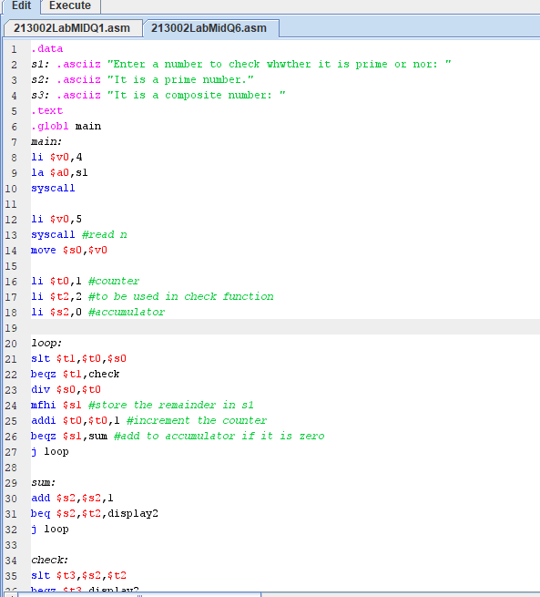

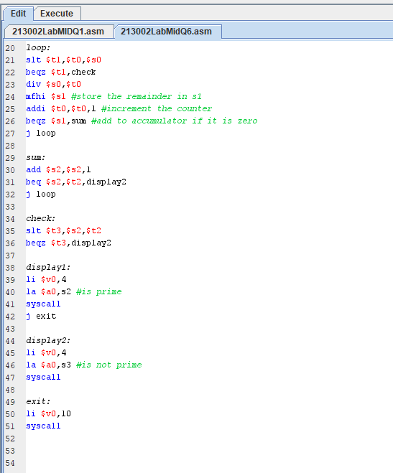

**Output:**

